

**Airport System**

**User Document Report**

**Database**

**10204282**

**A/618/7400**

**Section (2)**

**Submitted by**

Hamza AL-Risheq

**Submitted to**

Dr.Rami Ibrahim

**summer 2022 – 2023**

Table of Contents

1 User Documentation 3

1.1 System Overview 3

1.2 Using the system 3

1.3 Frequently asked questions 6

1.3.1 Question one 6

1.3.2 Question two 7

1.4 Contact information 7

# User Documentation

## System Overview

I build a system that meets the airport requirements. This system will allow all the users based on their privileges to access the database via a GUI and do what they are available to do. So, of the features that my system provides for the user view existing records, add a new record, delete, and modify records.

## Using the system

To visit the website you must search for this link by using a browser: <http://localhost/PHP/airport/>

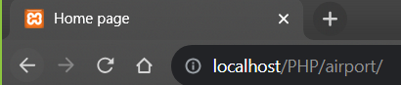

Then the home page will be displayed on your screen: the home page contains the links for another 5 pages as you can down there.

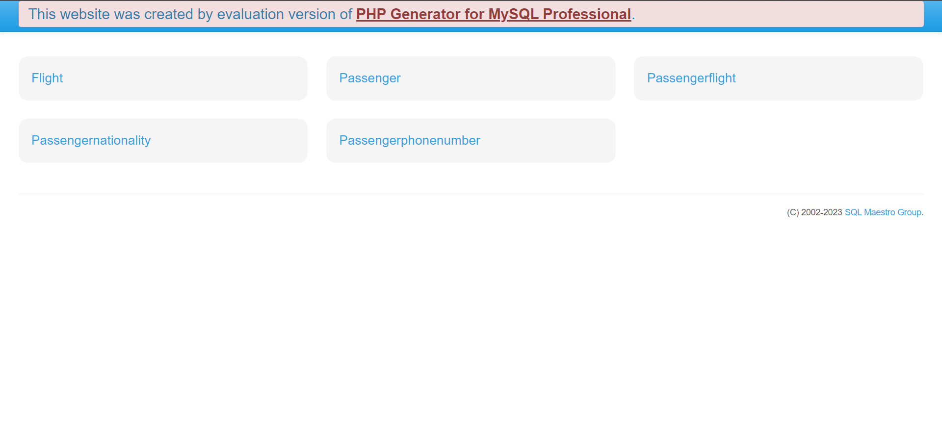

If you clicked on one of these title pages, it will take you to the page you clicked on it. Each page has a specific feature.

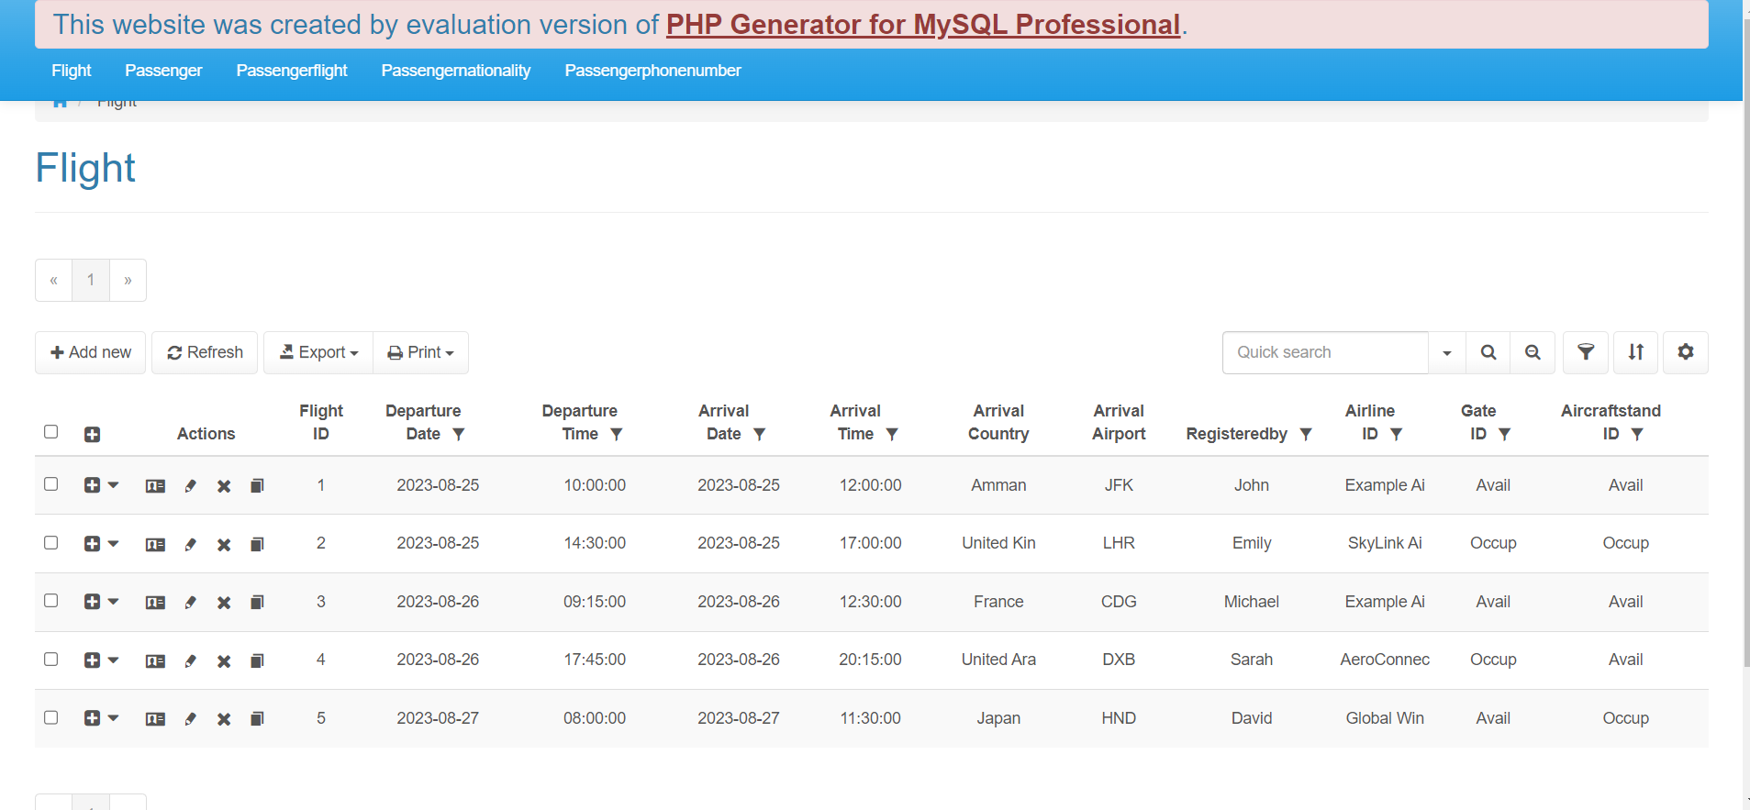

To delete this row

To view the data in this row

Navigation Bar

To search about something in the table

To copy the data in this row

To print the data in this table

To export the data to your device

To refresh the page

To Add new row in the table

To edit the data in this row

If you clicked on the add new button it will take you to the adding page:

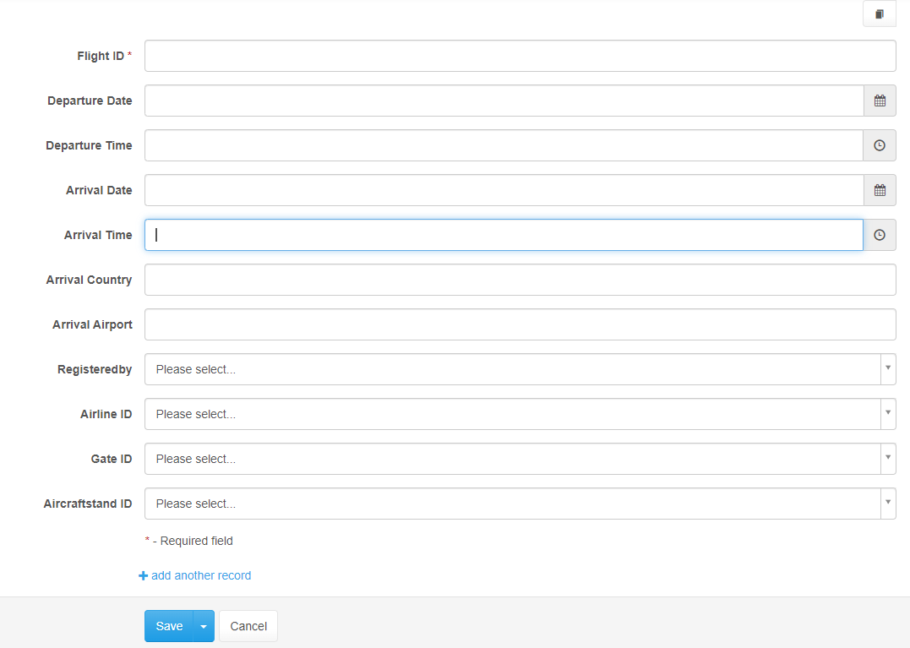

To add multiple records within the same time

To save the new record

To cancel adding record operation

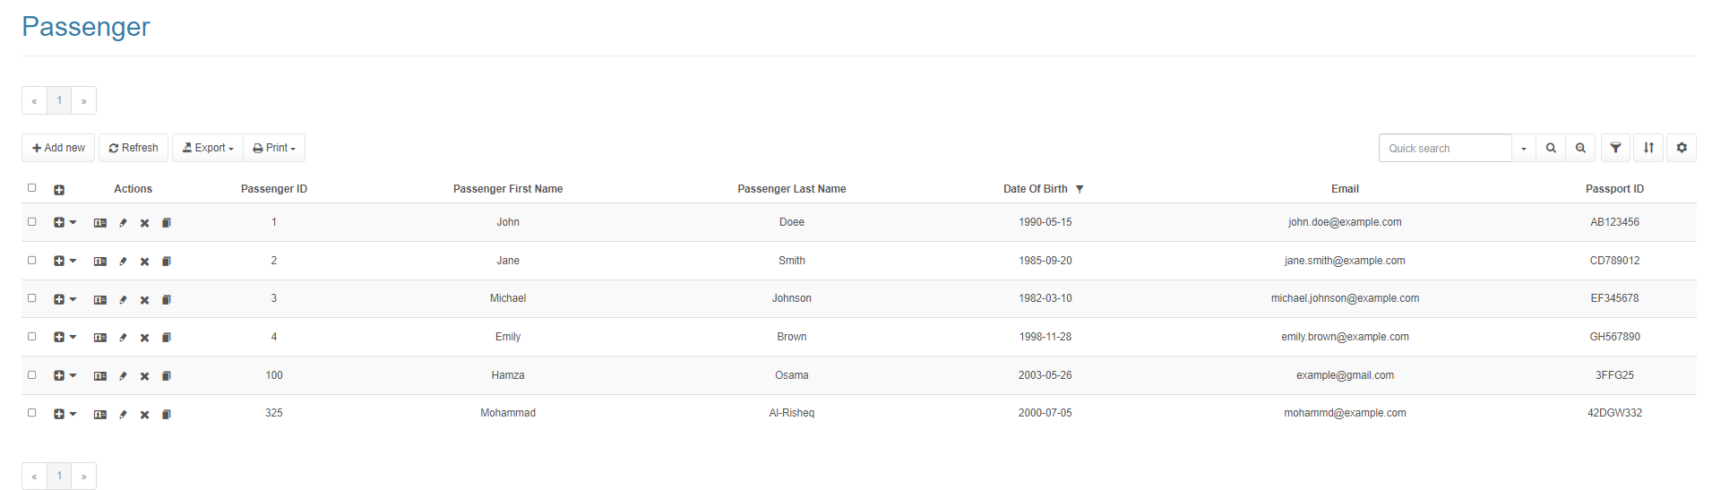

This page displays all the entered passengers in the airport, by bringing these data from the airport database, from the passenger table. As we can see in the passenger page there are several provided features such as deleting, edit, updating, inserting, printing the table, and view a specific row. So, we can insert new row to the table by clicking on the ADD NEW button. We edit the row by clicking on the pencil icon in the row, we can delete a row from the table by clicking on the X icon in the rows. Or we can print the tables by clicking on the print button. If you want to view a specific a row you can press on the profile icon in the row.

This page displays all flights that the passenger reserved on it, by bringing these data from the airport database, from the passengerflight table. As we can see in the passenger page there are several provided features such as deleting, edit, updating, inserting, printing the table, and view a specific row. So, we can insert new row to the table by clicking on the ADD NEW button. We edit the row by clicking on the pencil icon in the row, we can delete a row from the table by clicking on the X icon in the rows. Or we can print the tables by clicking on the print button. If you want to view a specific a row you can press on the profile icon in the row.

This page displays all nationalities for the passenger, by bringing these data from the airport database, from the passengernationality table. As we can see in the passenger page there are several provided features such as deleting, edit, updating, inserting, printing the table, and view a specific row. So, we can insert new row to the table by clicking on the ADD NEW button. We edit the row by clicking on the pencil icon in the row, we can delete a row from the table by clicking on the X icon in the rows. Or we can print the tables by clicking on the print button. If you want to view a specific a row you can press on the profile icon in the row.

This page displays all the phones number for the passenger, by bringing these data from the airport database, from the passengerphonenumber table. As we can see in the passenger page there are several provided features such as deleting, edit, updating, inserting, printing the table, and view a specific row. So, we can insert new row to the table by clicking on the ADD NEW button. We edit the row by clicking on the pencil icon in the row, we can delete a row from the table by clicking on the X icon in the rows. Or we can print the tables by clicking on the print button. If you want to view a specific a row you can press on the profile icon in the row.

This page displays all the flights that are registered in the airport, by bringing these data from the airport database, from the flight table. As we can see in the passenger page there are several provided features such as deleting, edit, updating, inserting, printing the table, and view a specific row. So, we can insert new row to the table by clicking on the ADD NEW button. We edit the row by clicking on the pencil icon in the row, we can delete a row from the table by clicking on the X icon in the rows. Or we can print the tables by clicking on the print button. If you want to view a specific a row you can press on the profile icon in the row.

## Frequently asked questions

Filtering icon.

### 1.3.1 Question one

Does this system have a filtering feature to filter the data in the table?

Yes, we can see it from the screenshot.

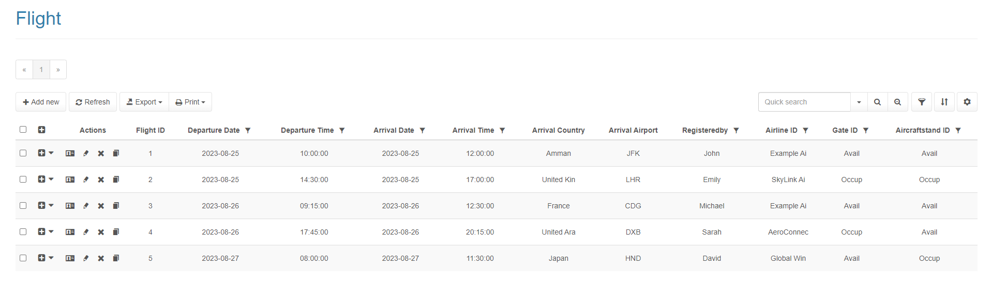

If you clicked on the filter icon it will show you this. To filter the data based on the specifier you choose.

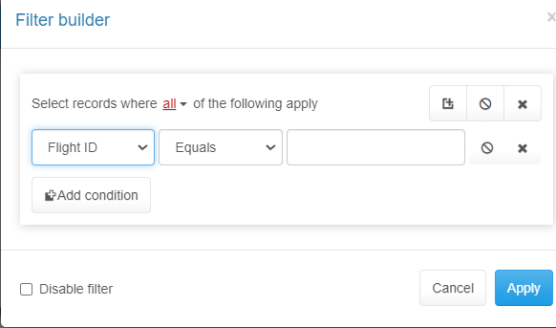

### 1.3.2 Question two

Sorting Icon

Is there an option to sort the data based on my choose?

Yes, there is.

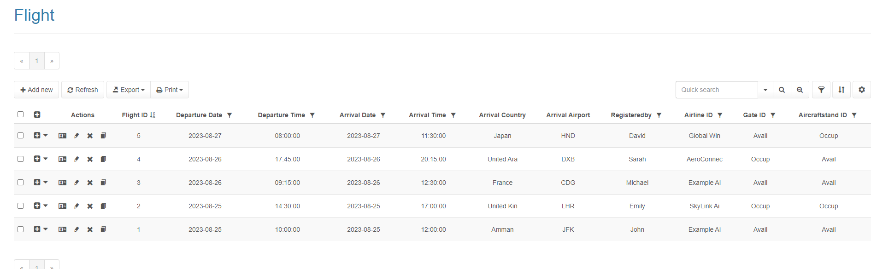

If you clicked on the sorting icon it will show you this to sort the data based on your sorting way you specify.

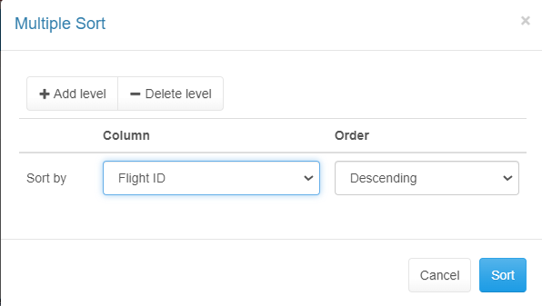

## Contact information

To contact us via email: queenaliairport@gmail.com

To contact us via phone: +962 778656985

Instagram link: <https://instagram.com/_hamzx20?utm_source=qr&igshid=ZDc4ODBmNjlmNQ%3D%3D>